Instructions:

- Pull the information from LoopNet listing or from the Set-Up Sheet, or info from broker or seller.
- Emphasize the sales features.
- Have good representative pictures.
- Please make sure the math is correct!
- Make sure Table of Contents is correct
- Delete this instruction page when done!
Executive Summary
Discounted Investment Opportunity

XYZ Apartments
53-Unit Apartment Complex

999 Lake Boulevard
Dallas, TX 75228

(photo)

Offered by:

Melvin Lamont Evans
(833)728-9278
melvin@sofiesentrepreneurialgroup.com

Table of Contents

Page

Contents
Investment Opportunity 3
Property Description 4
Income and Expenses 5
Property Highlights 6
Pictures 7
Confidentiality 9
Disclaimer 9
Contact Information 9

Insert Photo if available

Investment Opportunity

Purchase Price: $1,335,000 Cost per door: $25,190

Building Class: C

Location Class: C

Investment Benefits
- Priced to Move  - Cap Rate > 12%  - 100% Renovated 2007-2008  - Stable Property, 89% Occupancy  - Management in Place | - Low Down Payment  - Seller to Carry Back $150,000  - Seller pays Buyer $500 per vacant unit @ closing  - Rent Increase Upside

Pro Forma Value is $___________ (based on local market cap of 9%, 95% occupancy and 45% OE/GSI ratio). Per door Pro Forma is $__________ .

Opportunity: Excellent opportunity for an investor to get on board with a stable and recently renovated property which offers a significant upside with rent increases. Low cash requirement as Seller agrees to carry back $150,000 in financing for 48 months at 7% interest only.
Status: Under contract by Sofie’s Investment Group, LLC. New Buyer will be assigned the contract to close.

This Property is offered for sale to qualified Buyers.
Proof of funds is required with all offers.

Property Description

Unit Mix
Type | # of Units
1 BDR/1 BA | 13
2 BDR/1 BA | 12
2 BDR/1.5 BA | 22
3 BDR/2 BA | 6

Number of Units: 53

Style: Two-story, garden type

Electric: Individually Metered

HVAC: Central A/C & Heat

Roof: Pitched and Flat (replaced 2007-2008)

Construction: Concrete Slab, Wood Frame, Brick and Wood Exterior, Pitched Roof,
Asphalt Parking

Current Occupancy: 89%

CAP Rate: 12.2%

Building Square Footage: 167,982

Land Area: 3.5 acres

Built: 1969, renovated 2007-2008

Amenities: Sparkling Swimming Pool, Tennis Court, Jacuzzi, Hot Tub, Sauna, Exercise Room, Clubhouse, Playground, On-Site Laundry Facility, Ample Parking, Main Gate, On-Site Patrol, Bus Stop is (4) Blocks Away

Unit Amenities: Full-Size Washer/Dryer Connections, Fireplace, Patios/Balconies, Walk-In Closets, Central Air, Dishwasher, Disposal

Income and Expenses

Unit Income

Type | # of Units | Market Rent
1 BDR/1 BA | 13 | $500
2 BDR/1 BA | 12 | $600
2 BDR/1.5 BA | 22 | $650
3 BDR/2 BA | 6 | $750

Subject Property Rent: $490 to $770 per month. Actual rents are provided in the Rent Roll

Income | Pro-Forma
Monthly Potential Income | $390,000
Other Income | 4,073
Gross Scheduled Income | 394,073
Less Vacancy (10%) | (39,407)
Less Expenses (45%) | (177,332)
Net Operating Income | $177,332

Property Highlights

- Stable investment property that has been recently renovated on interior and exterior (roofs, paint, appliances, HVAC units).
- Stable occupancy with opportunity for rent increases and further valuye creation.
- Priced to move with Seller financing.
- Great and diverse unit mix and individually metered – residents pay for electricity
- Strong management infrastructure – on-site leasing office and laundry room.
- Perimeter fencing and gated.
- Excellent exposure to drive-by traffic, with easy access to I-30.
- Near retail and commercial services.
- Near area amenities include DART bus service and White Rock Lake.
- Centrally located between Hwy 45 and Hwy 290 allowing tenants easy access to employment, shopping, and entertainment
- Three airports are nearby, including the George Bush Intercontinental Airport, which is the 2nd largest airport in Texas
- Property is located within walking distance of area schools
- Metro Bus Stop is (4) blocks away from property
- Shopping, dining and popular entertainment are just minutes away
- Property has beautiful curb appeal with trees and well maintained lawns
- Playground area for the children and crystal clear pool to enjoy with friends
- Located in a quiet residential area with (350) parks in the Houston area to enjoy


Nearby Park in Houston, TX

Pictures

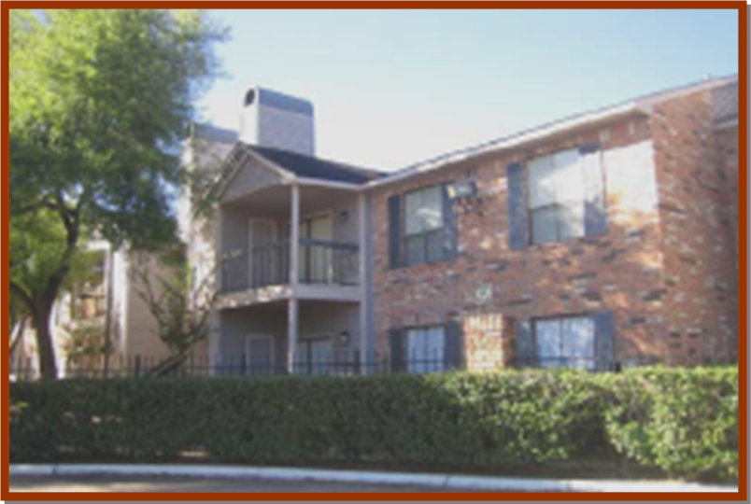

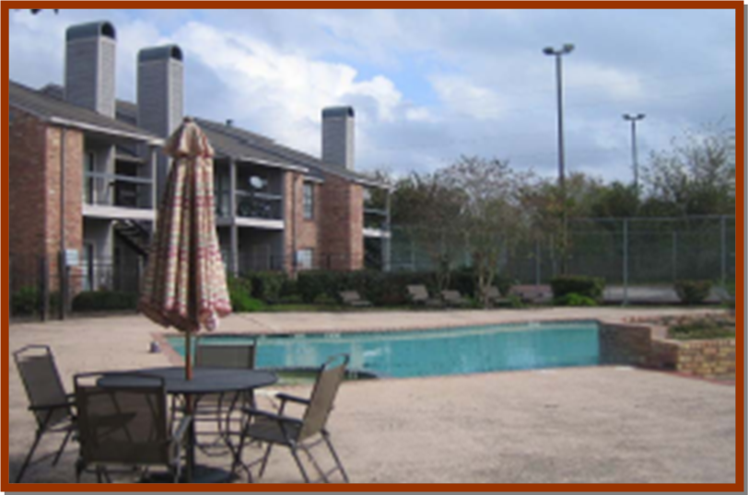

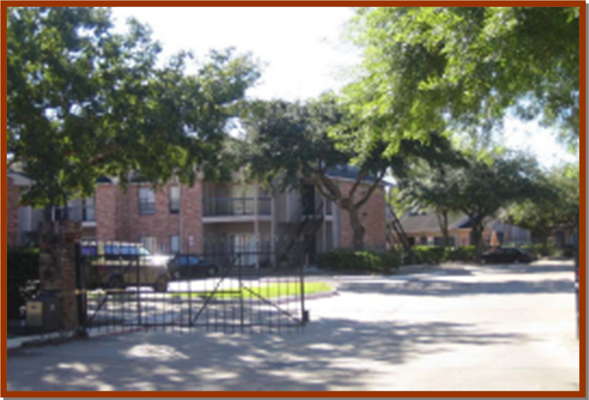

Confidentiality

It is acknowledged by reader that information furnished in this Executive Summary is in all respects confidential in nature, other than information which is in the public domain through other means and that any disclosure or use of same by reader, may cause serious damage; therefore, reader agrees not to disclose it without the express written permission of Sofie’s Investment Group, LLC.

Disclaimer

Sofie’s Investment Group, LLC has prepared this Executive Summary, which contains brief, selected information pertaining to the business and affairs of the property. The information contained herein does not purport to be all inclusive nor does it purport to contain all of the information representative of the property. Sofie’s Investment Group, LLC nor any of its respective partners, officers, employees or agents makes any representation or warranty, expressed or implied, as to the accuracy or completeness of the information contained herein or otherwise expressed and conveyed and no legal liability is assumed or shall be implied with respect hereto.

Such information and statements have in many circumstances been obtained from outside sources, have not been tested or verified and may be subject to errors or omissions. Projections, especially, are based on various assumptions and subjective determinations as to which no guaranty or assurance is given.

Potential investors are recommended and urged to perform their own examination and investigation and not to rely on the information contained within this document or other materials otherwise provided.

Contact Information

Please contact me at the phone number or email address listed below if you are an interested party, or if you require further information.

Melvin Lamont Evans: (833)728-9278
Sofie’s Investment Group, LLC

or email:

melvin@sofiesentrepreneurialgroup.com

